**Exercise 7.32: Partition of a List**

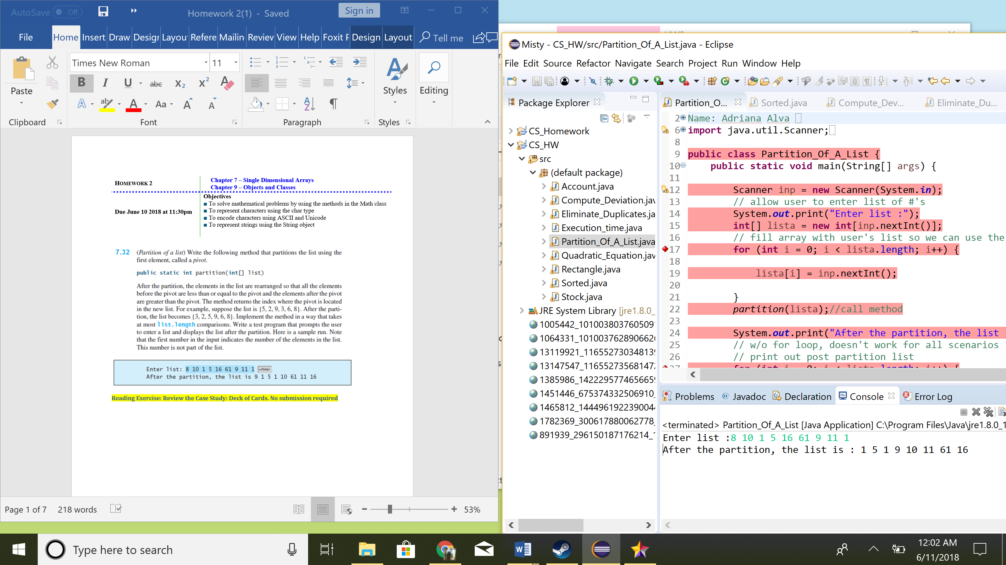

Comments:

* Method public static int partition(int[] list)

**Exercise 7.11: Compute Deviation**

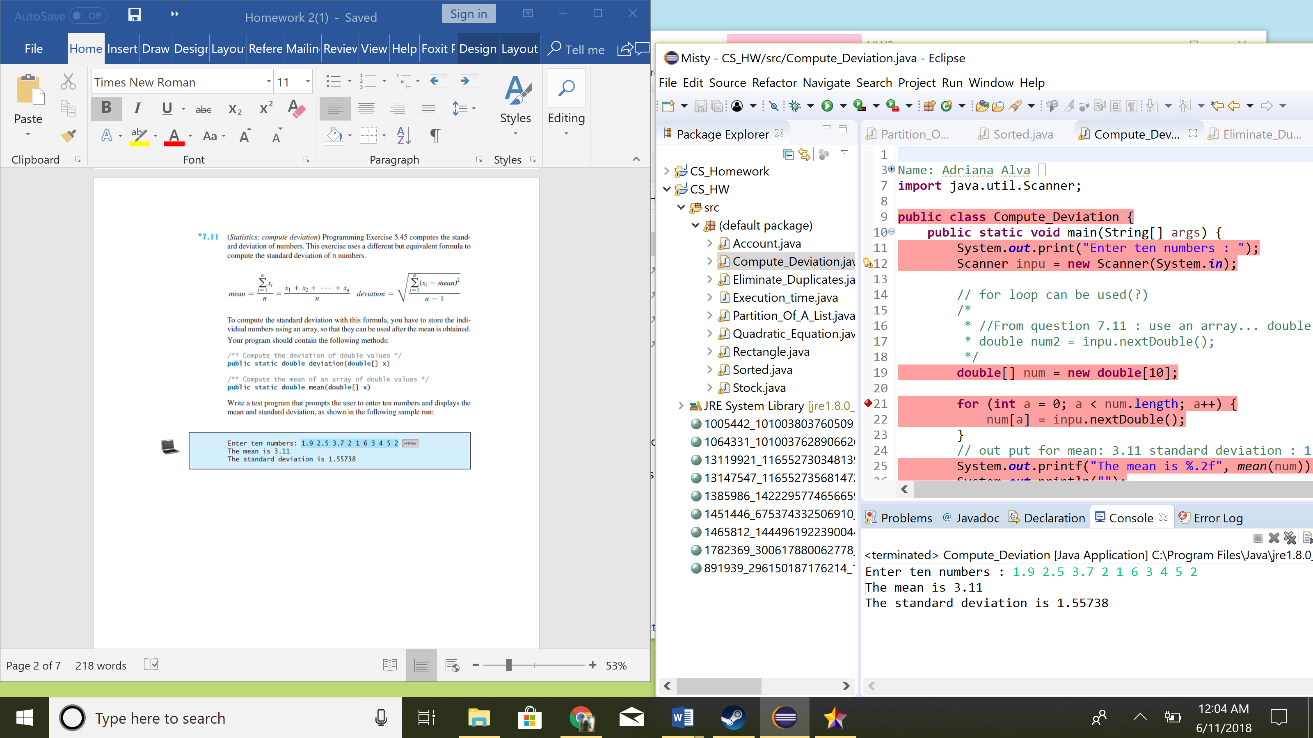

Comments:

* Method public static double deviation(double[] x)
* Method public static double mean(double[] x)
* Format display for mean and standard deviation

**Exercise 7.15: Eliminate Duplicates**

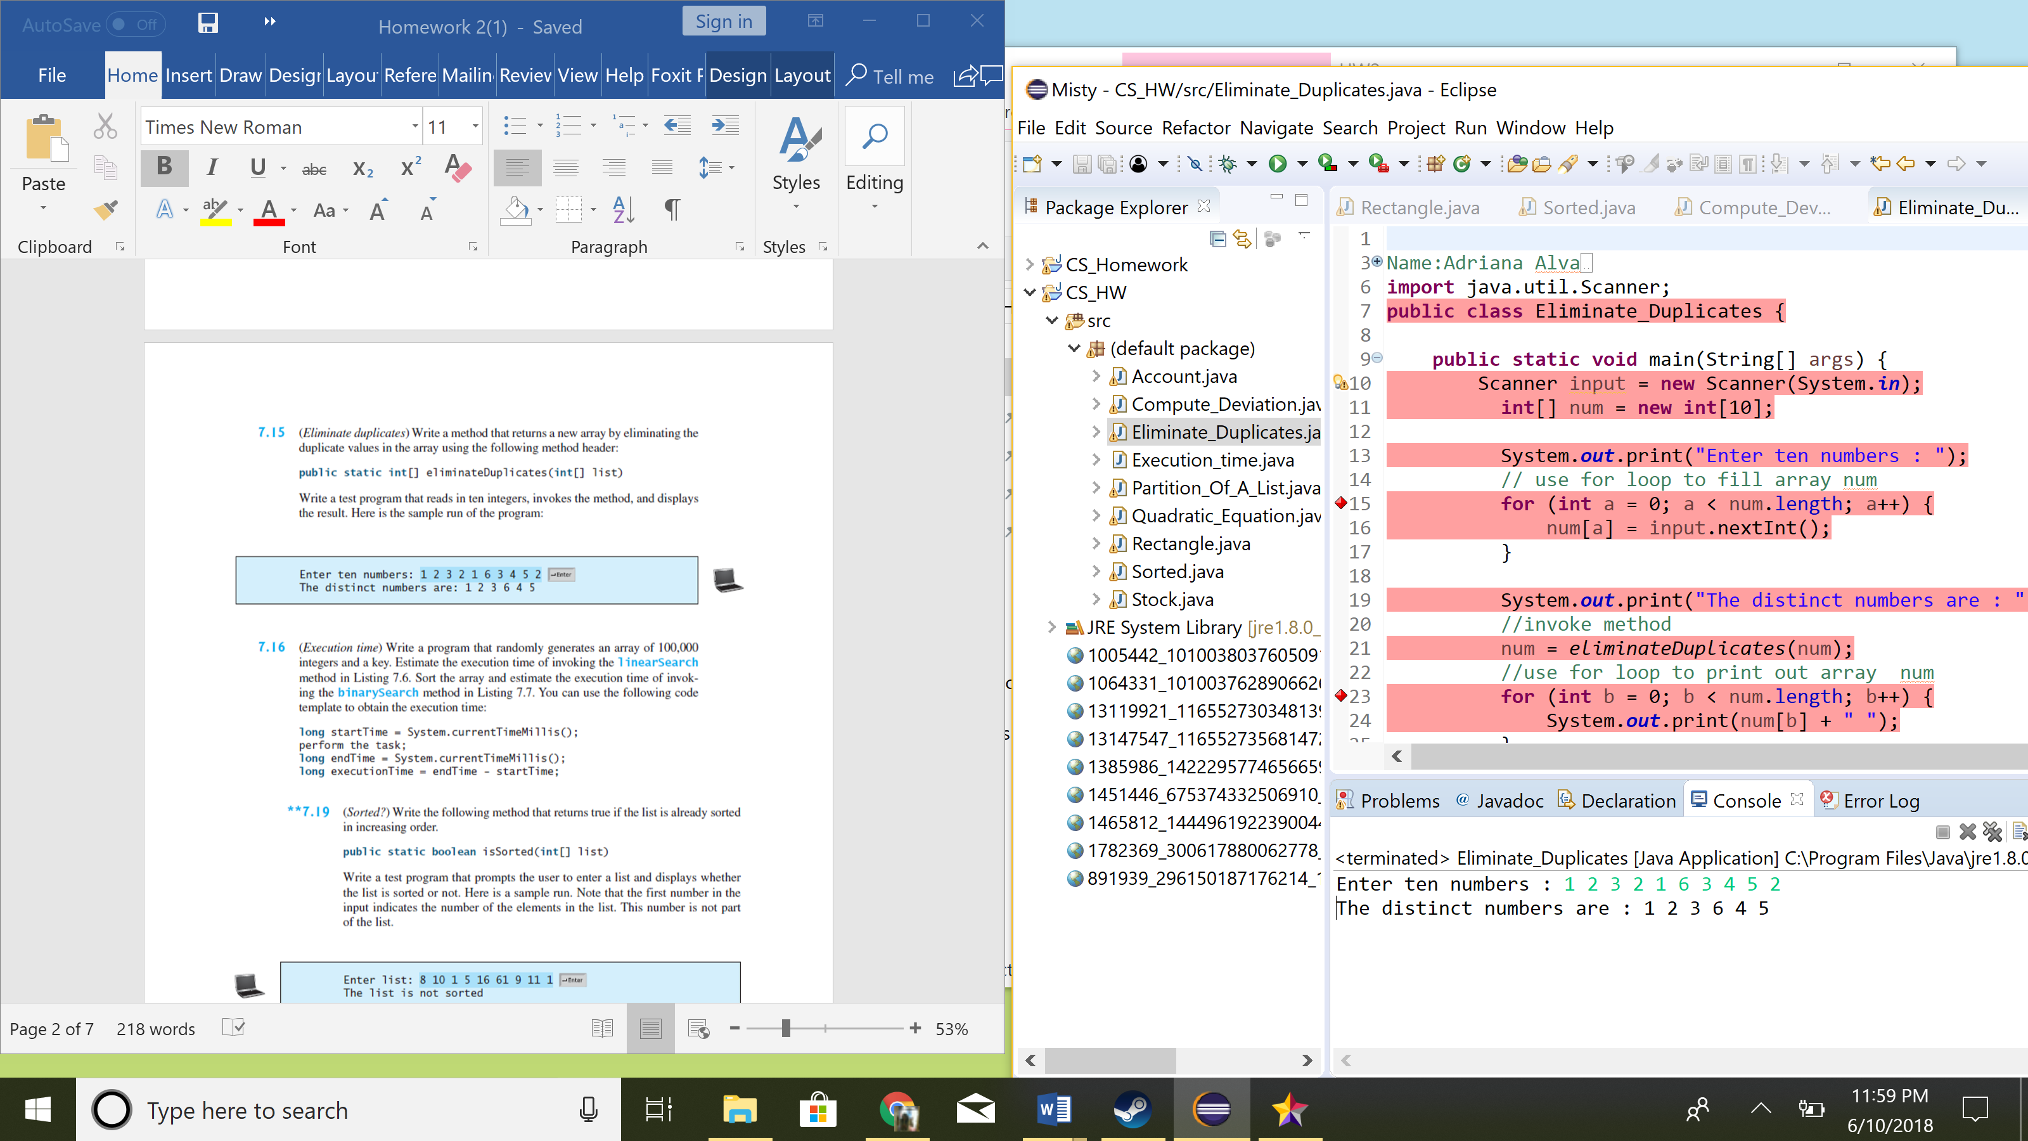

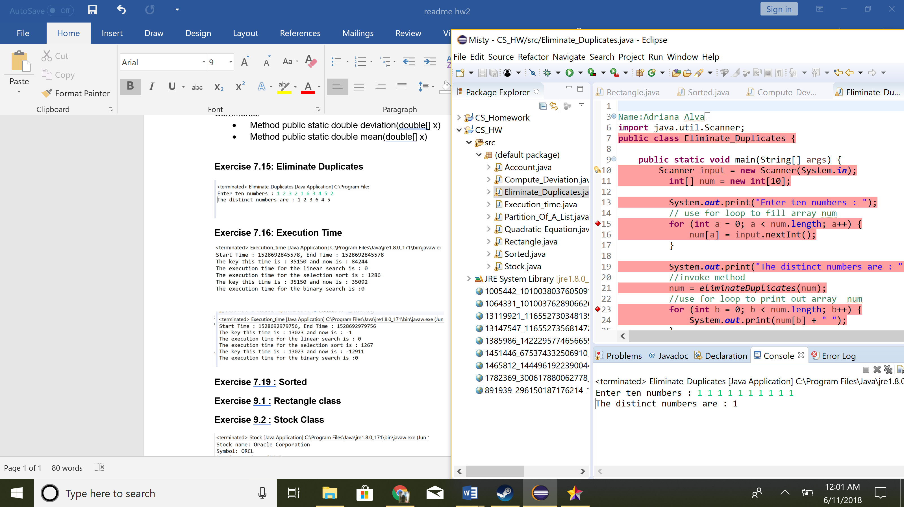

**Exercise 7.16: Execution Time**

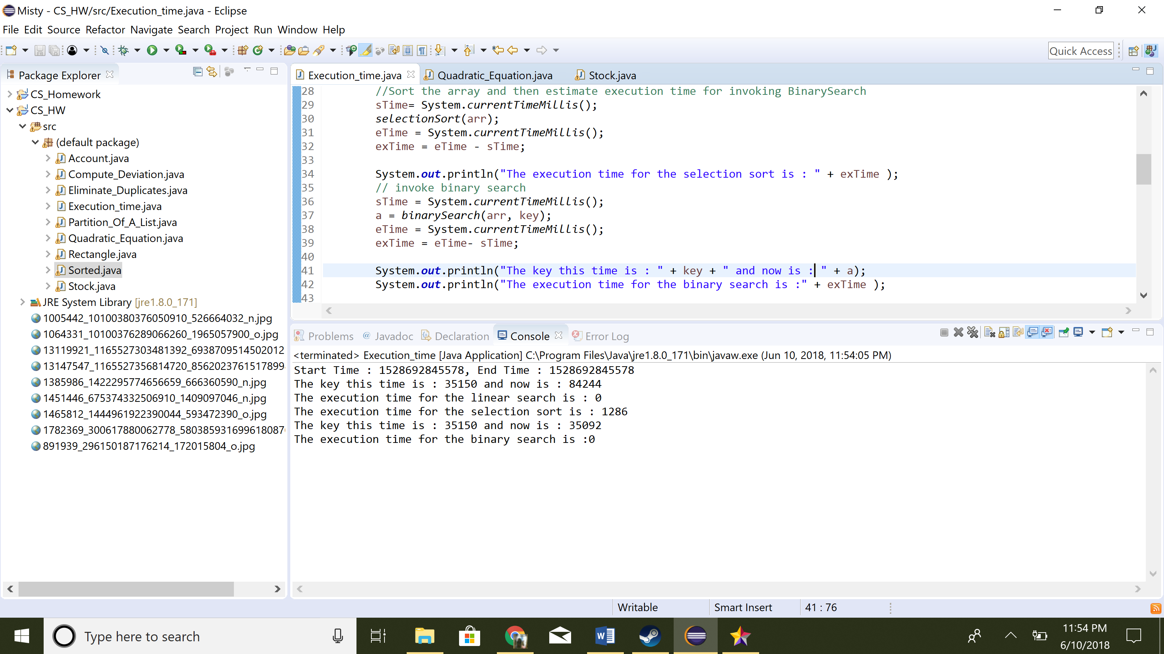

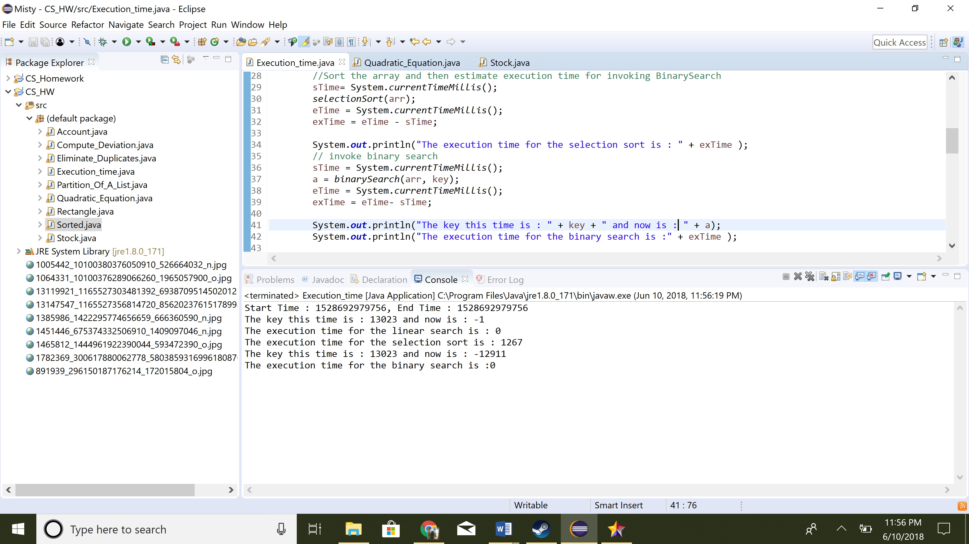

**Exercise 7.19 : Sorted**

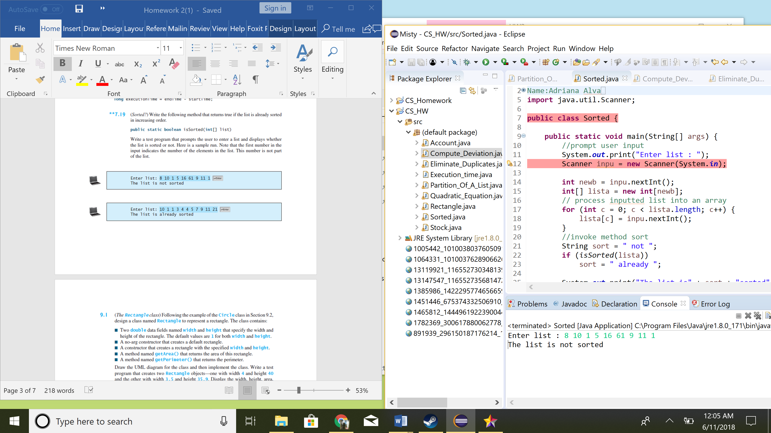

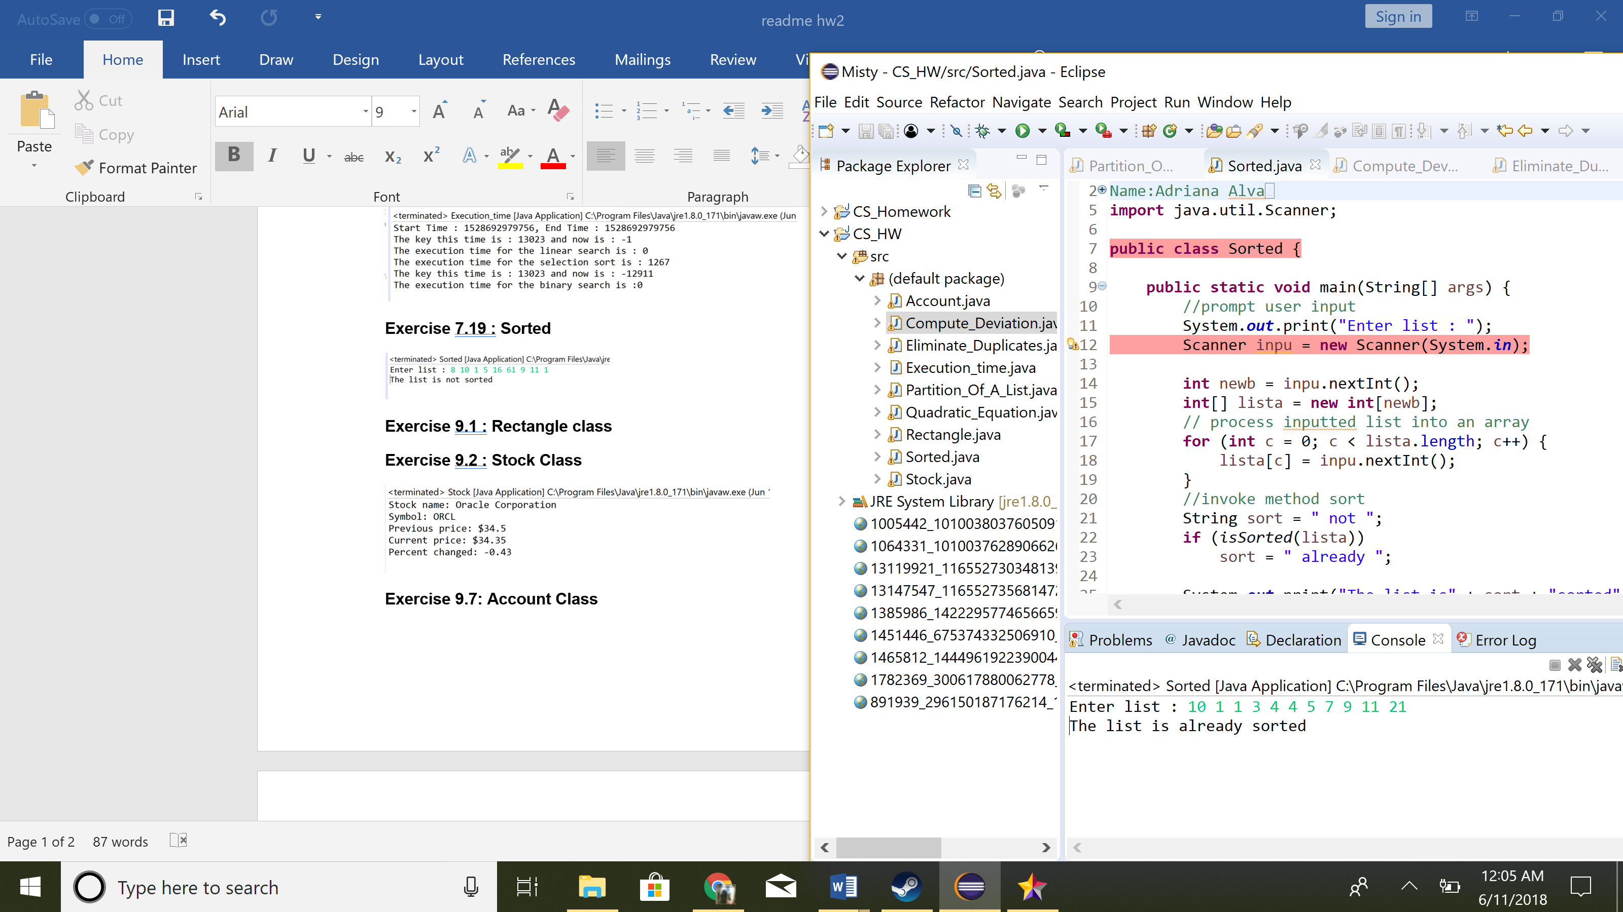

**Exercise 9.1 : Rectangle class**

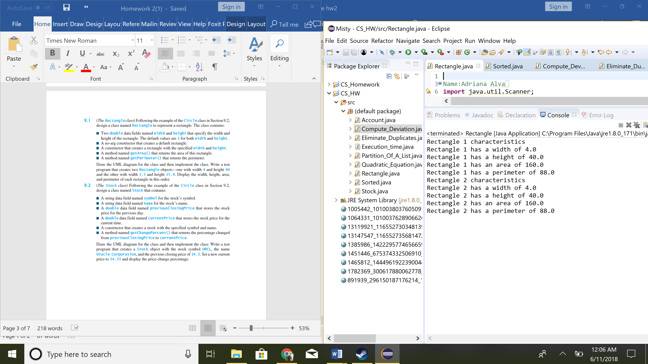

**Exercise 9.2 : Stock Class**

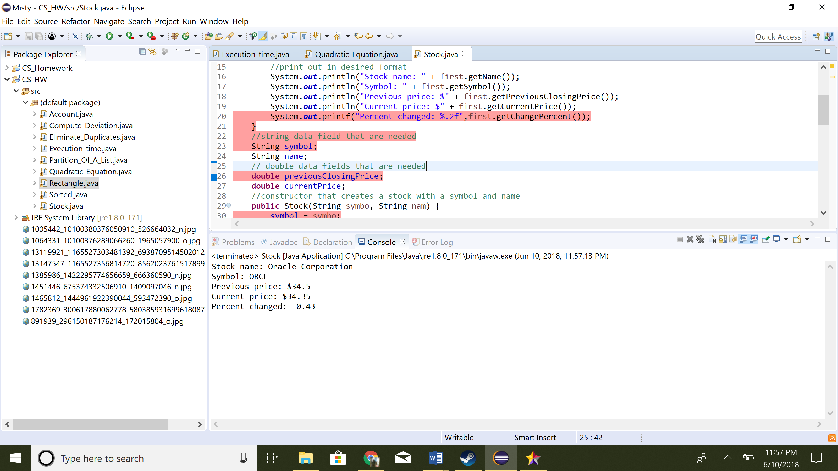

**Exercise 9.7: Account Class**

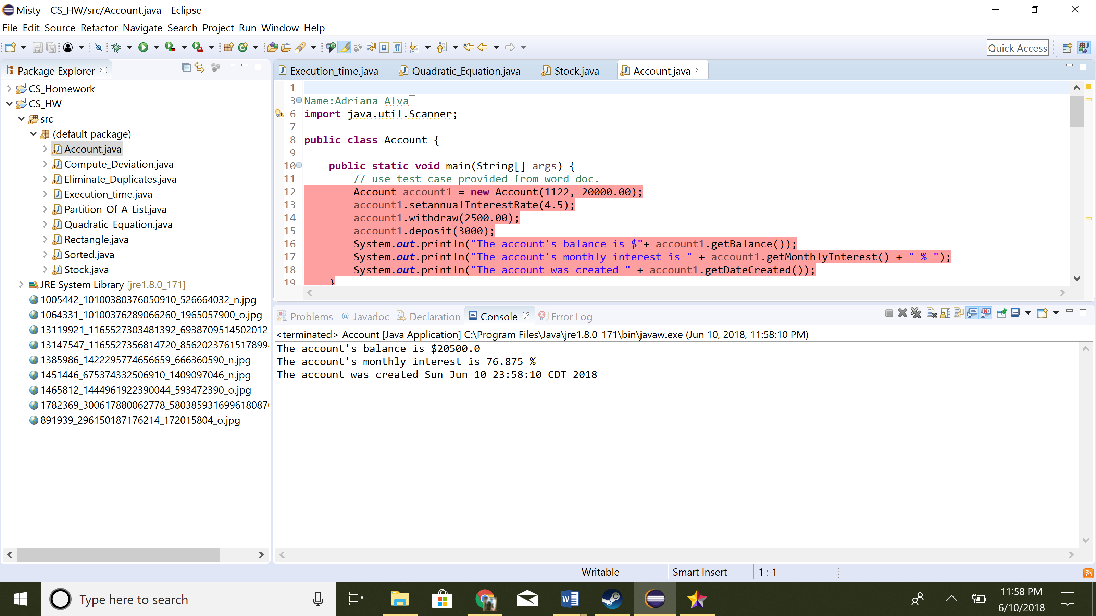

**Exercise 9.10: Quadratic Equations**

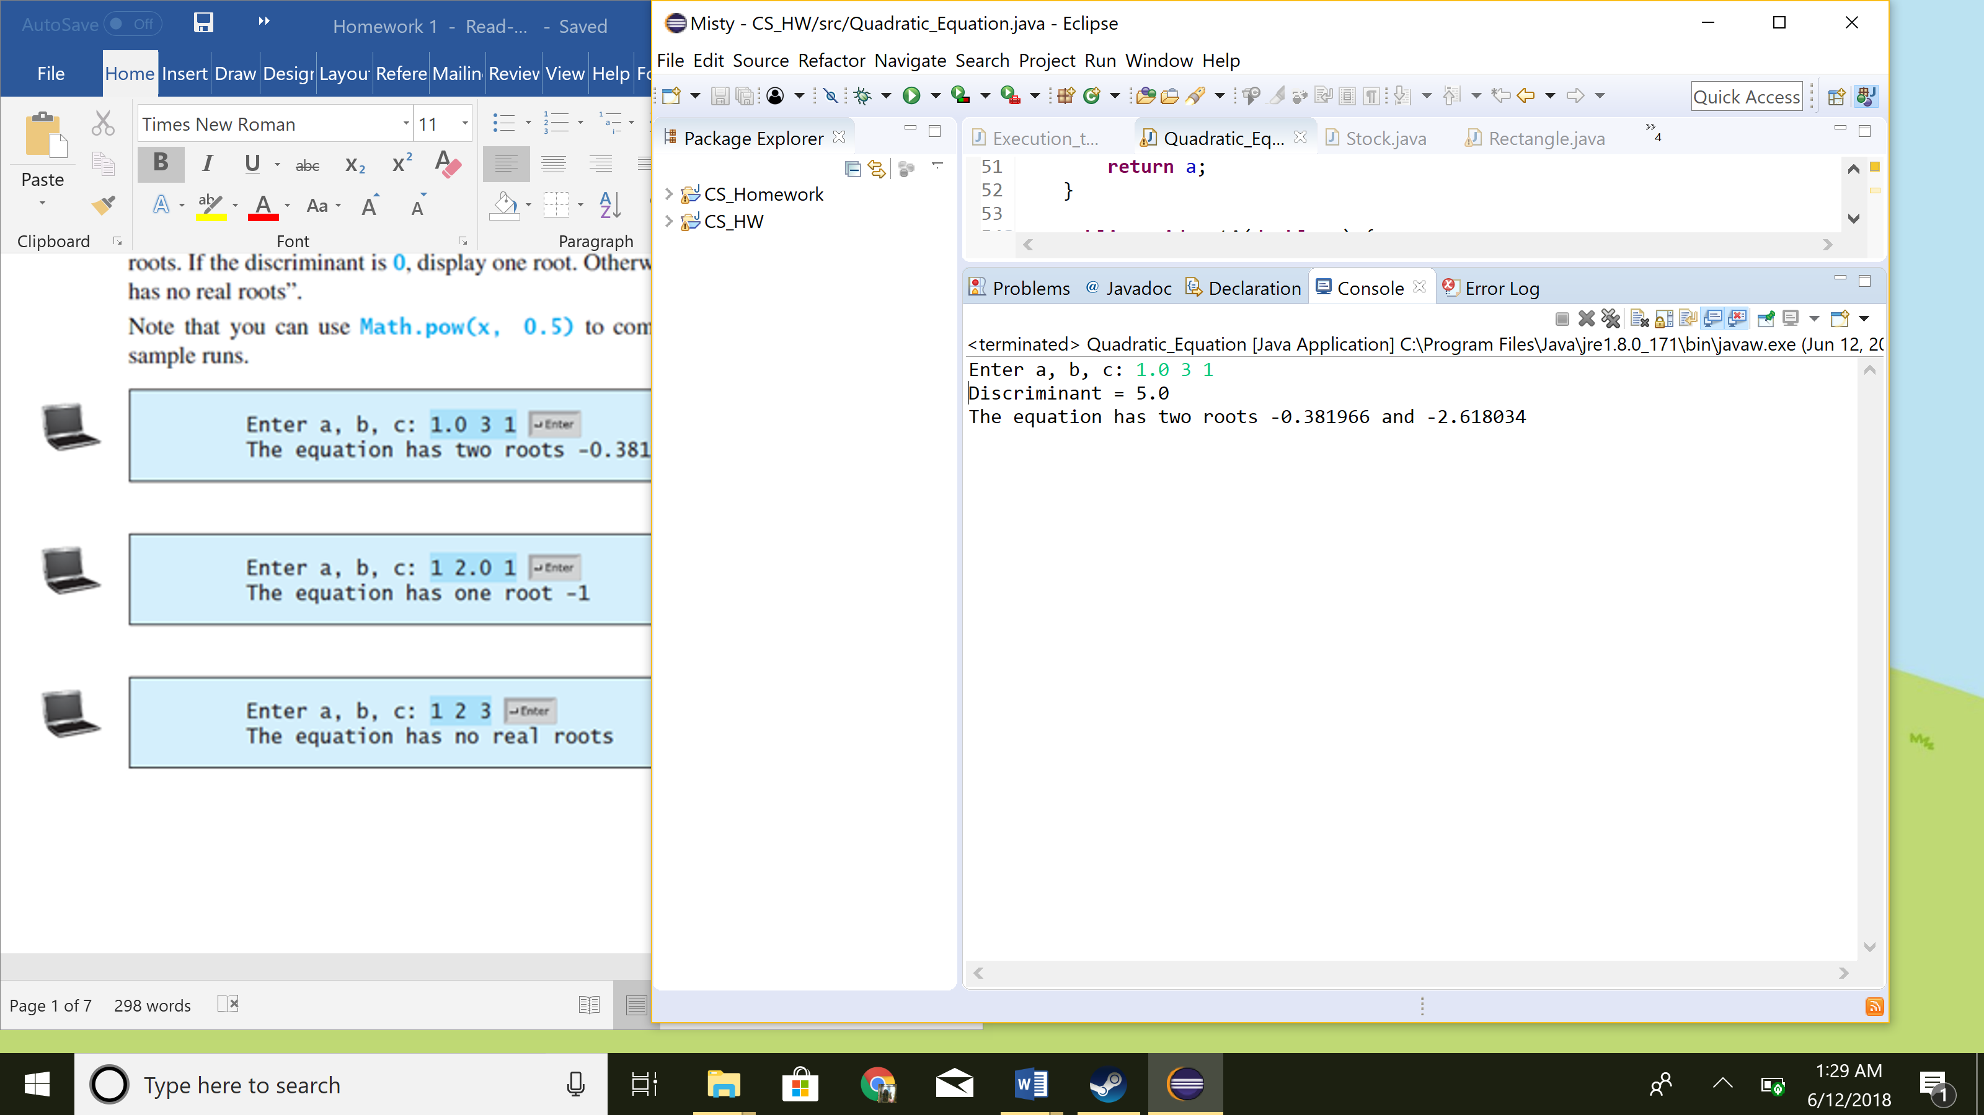

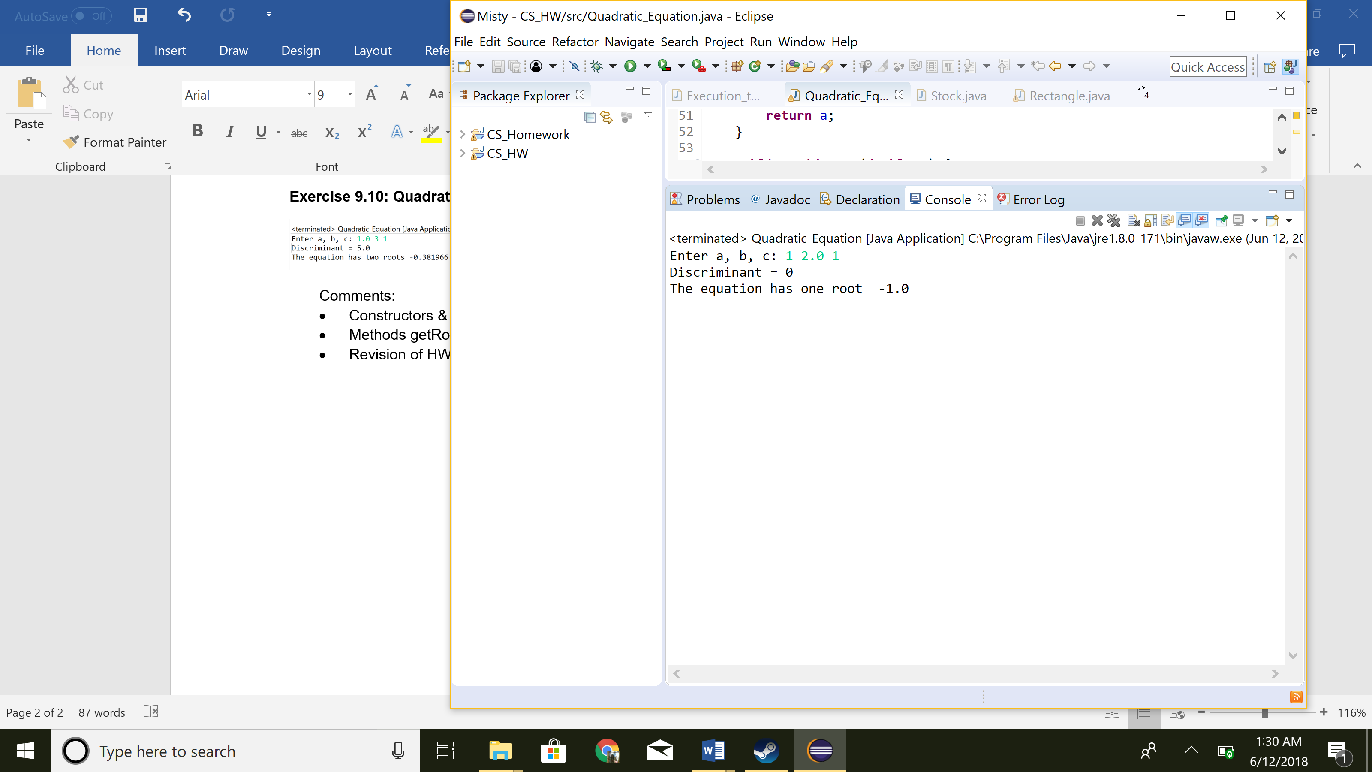

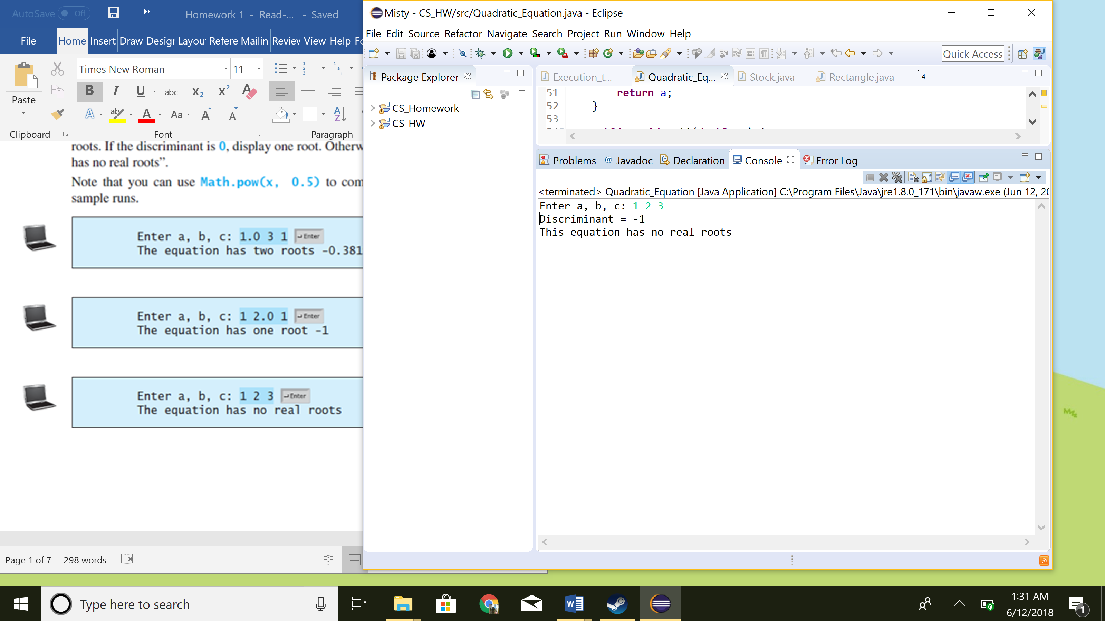

Comments:

* IF discriminant is zero: return 0   
  ELSE IF discriminant is negative: return -1   
  ELSE IF discriminant is positive: return value
  + Constructors & private data fields for a, b and c
  + Methods getRoot1(), getRoot2(), getDiscriminant()
  + Revision of HW1 quadratic equations